 Information Technology Institute

Data Warehouse Project

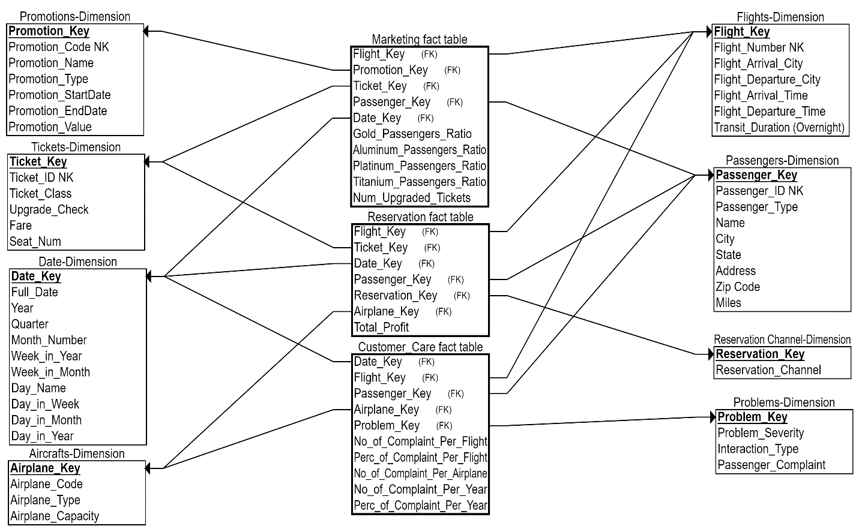

***In the previous Galaxy Schema, there are three fact tables.***

1. **Marketing**
2. **Reservation**
3. **Customer Care**

Each organizational unit benefits from its respective fact table. Fact tables have a number of connected dimensions. The three of them share the Passenger, Date, and Flights conformed dimensions. To break this down, we demonstrate each fact table separately.

1. **Marketing Fact Table:**connected to five Dimension Tables.

* + - Promotions Dimension: represents promotions offered by the airline company and their values. This dimension would allow the marketing team to measure the responsiveness of their frequent passengers to promotions.

* + - Passengers Dimension: represents passengers’ personal information and traveling miles they acquired which determines their type (Aluminum, Gold, Platinum, or Titanium).

* + - Date Dimension: represents the date at which the ticket has been bought. This dimension also illustrates the atomic granularity of our model.

* + - Tickets Dimension: represents the reserved ticket and the seat number. Upgrade_Check column is by default 0 and indicates whether the ticket class has been upgraded or not. Passengers can upgrade their tickets through their mileage credit or their Credit Card/ Debit Card.

* + - Flights Dimension: represents the flight’s destination and departure city. It also shows the transit duration from which we can deduce whether the passenger had to stay the night in.

1. **Reservation Fact Table:**connected to six Dimension Tables.
   * + Passengers Dimension: represents the passengers and their type, which can help the finance team analyze the profit attained from a specific passenger type.

* + - Date Dimension: as illustrated in the previous fact table, this dimension shows the granularity of our model.

* + - Flights Dimension: represents flights and the finance team can use it in analyzing the profit from each flight.

* + - Reservation Channel Dimension: represents the channel used to book the ticket (Booking Website, Mobile Application, Call Center, Sales Office, or Travel Agency) to analyze the most profitable channel.

* + - Tickets Dimension: represents the fare of the ticket as well as the ticket class.

* + - Aircrafts Dimension: This allows the finance team to keep track of the company’s expenses and to spot airplanes that require high maintenance costs.

1. **Customer Care Fact Table:**connected to five Dimension Tables.

* + - Passengers Dimension: this allows the team to segregate queries by passenger type or location.

* + - Date Dimension: this allows analysts to track passengers’ satisfaction over time.

* + - Flights Dimension: represents the flights and whether or not problems are related to a particular flight.

* + - Problems Dimension: represents passenger’s complaints and the severity of the problem.

* + - Aircrafts Dimension: represents airplanes data and their respective models to analyze airplane performance.